1. Give Bold for all headings. 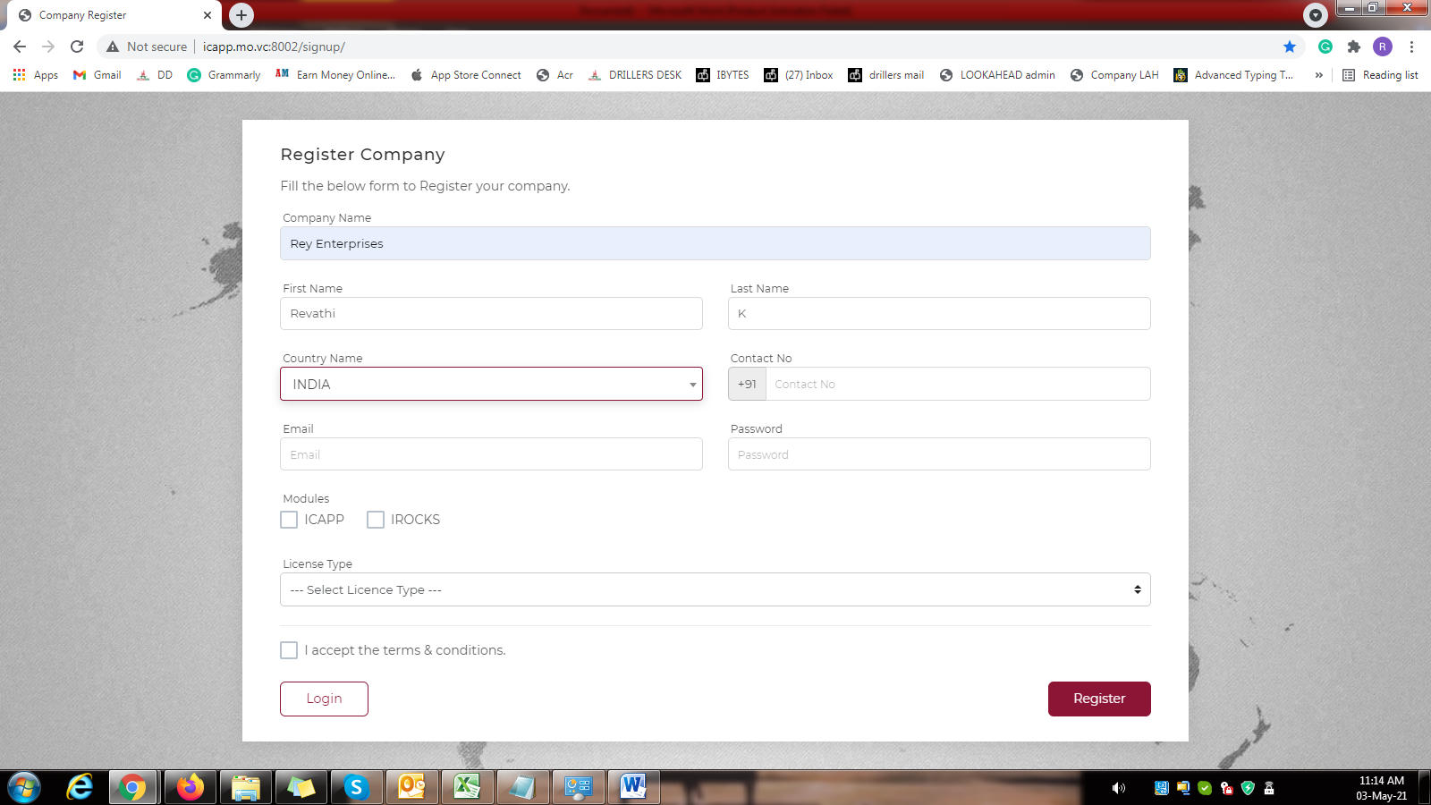
2. Give this in center and increase the font size for Register Company.

Change it as “Company Registration”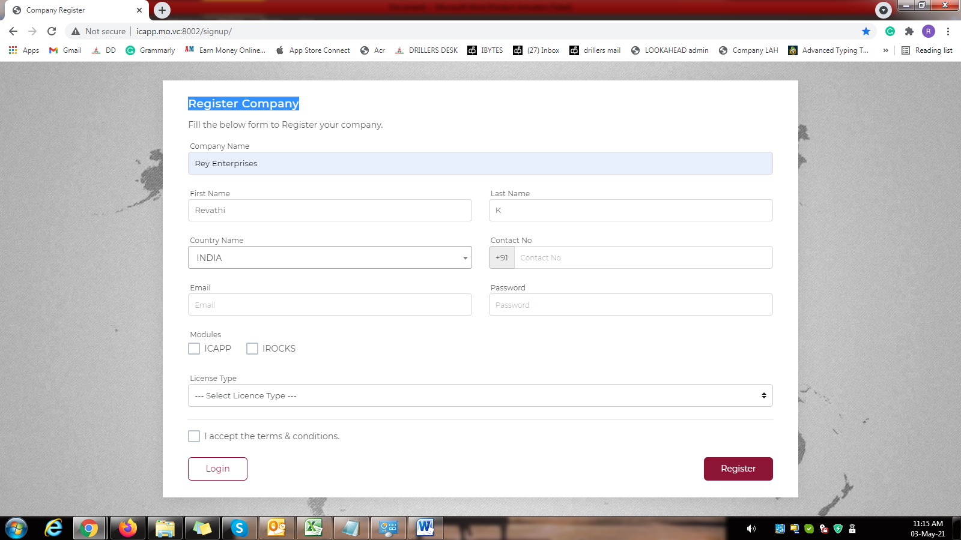

1. Give Register in Center and remove the login. Give Back icon.
2. Allow only one space. **Let us discuss**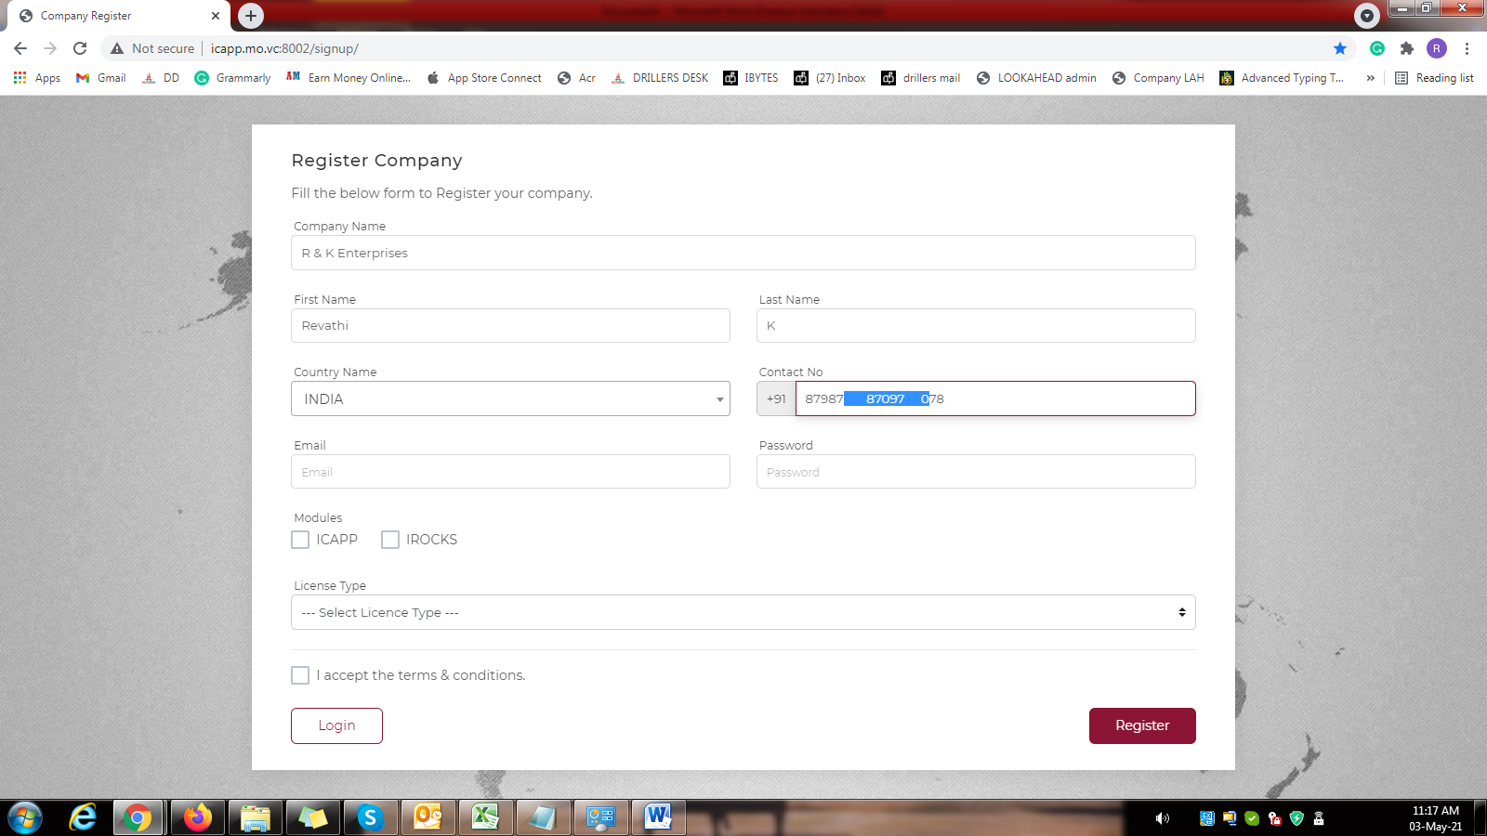
3. Should not allow the user to enter the alphabets in the mobile number field. 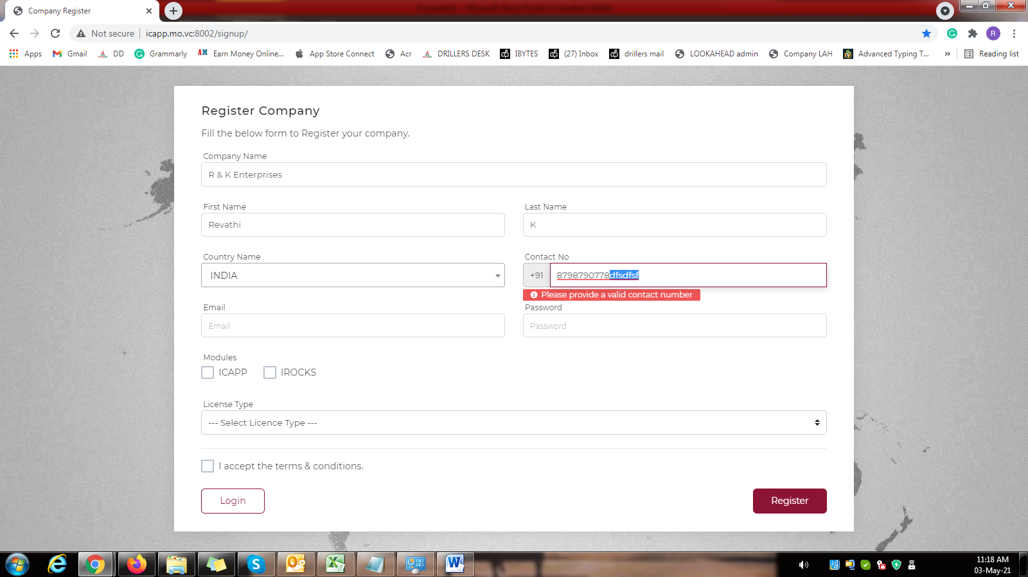
4. Mobile number restriction – Minimum 5 digits and maximum 20 digits including the spaces. 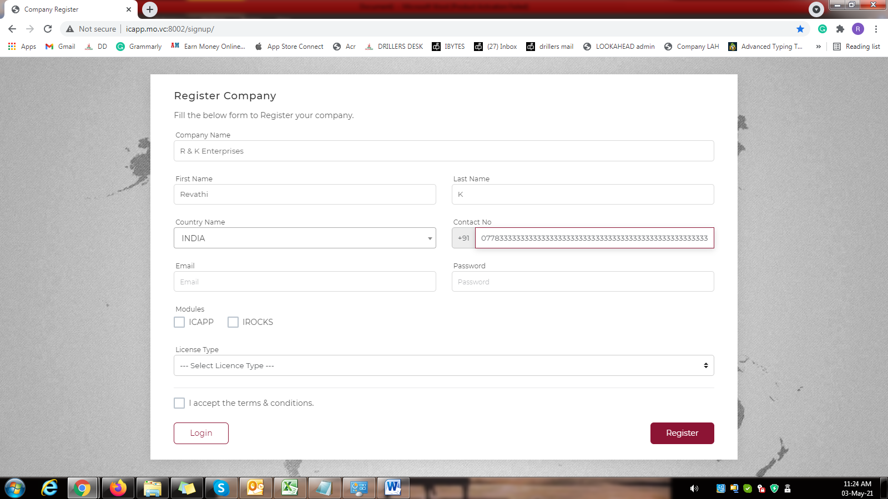
5. Give Eye icon for all password field. 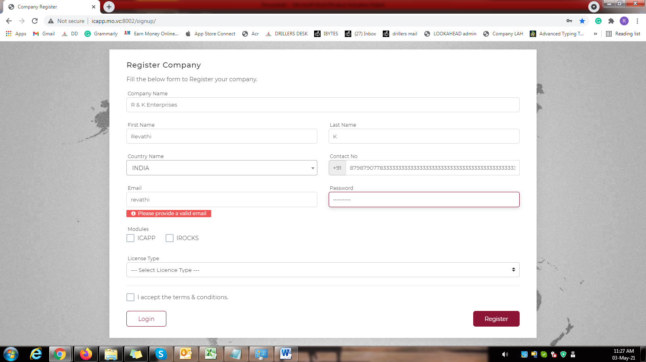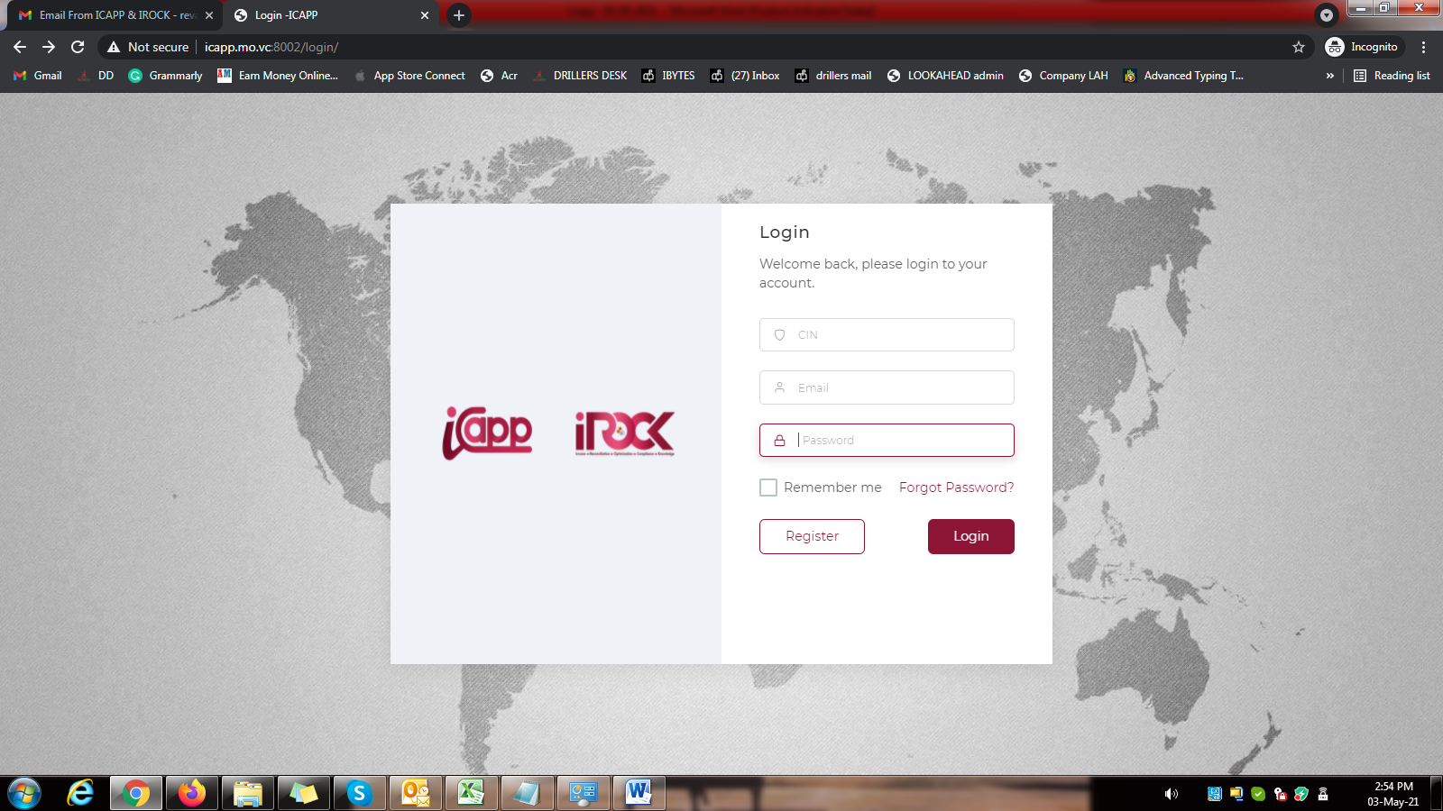
6. Give password warning as **“**Password should have minimum 8 letters consisting atleast one from A-Z, a-z, 0-9 and special characters” 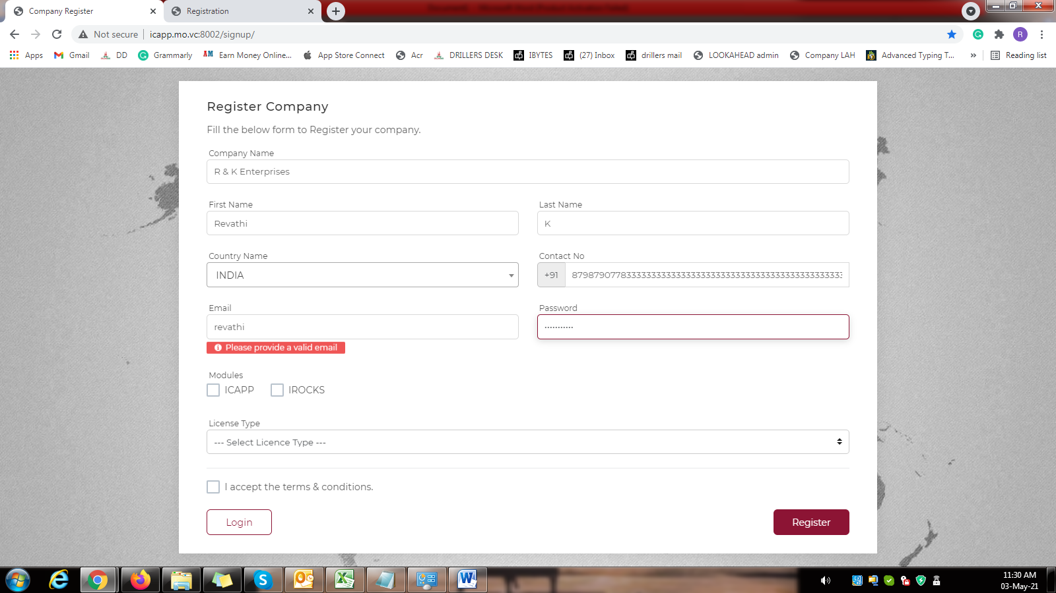
7. Give “of” in small letter.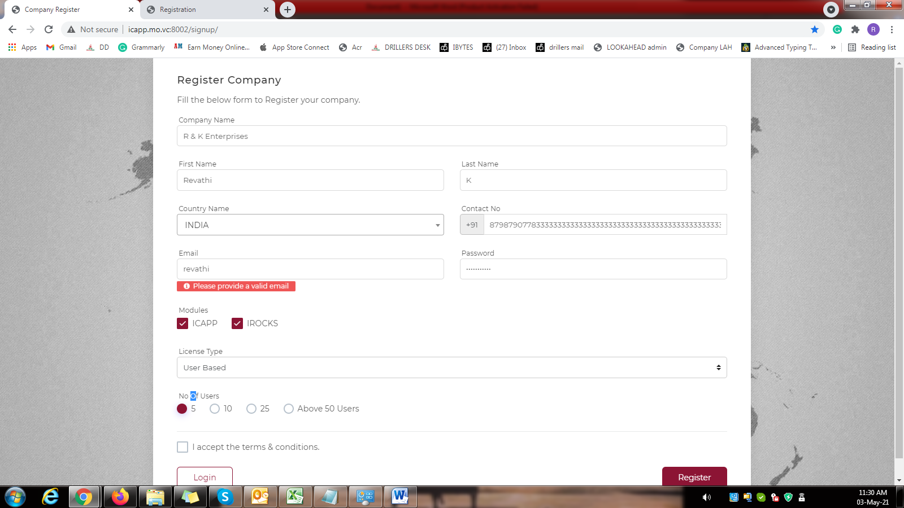 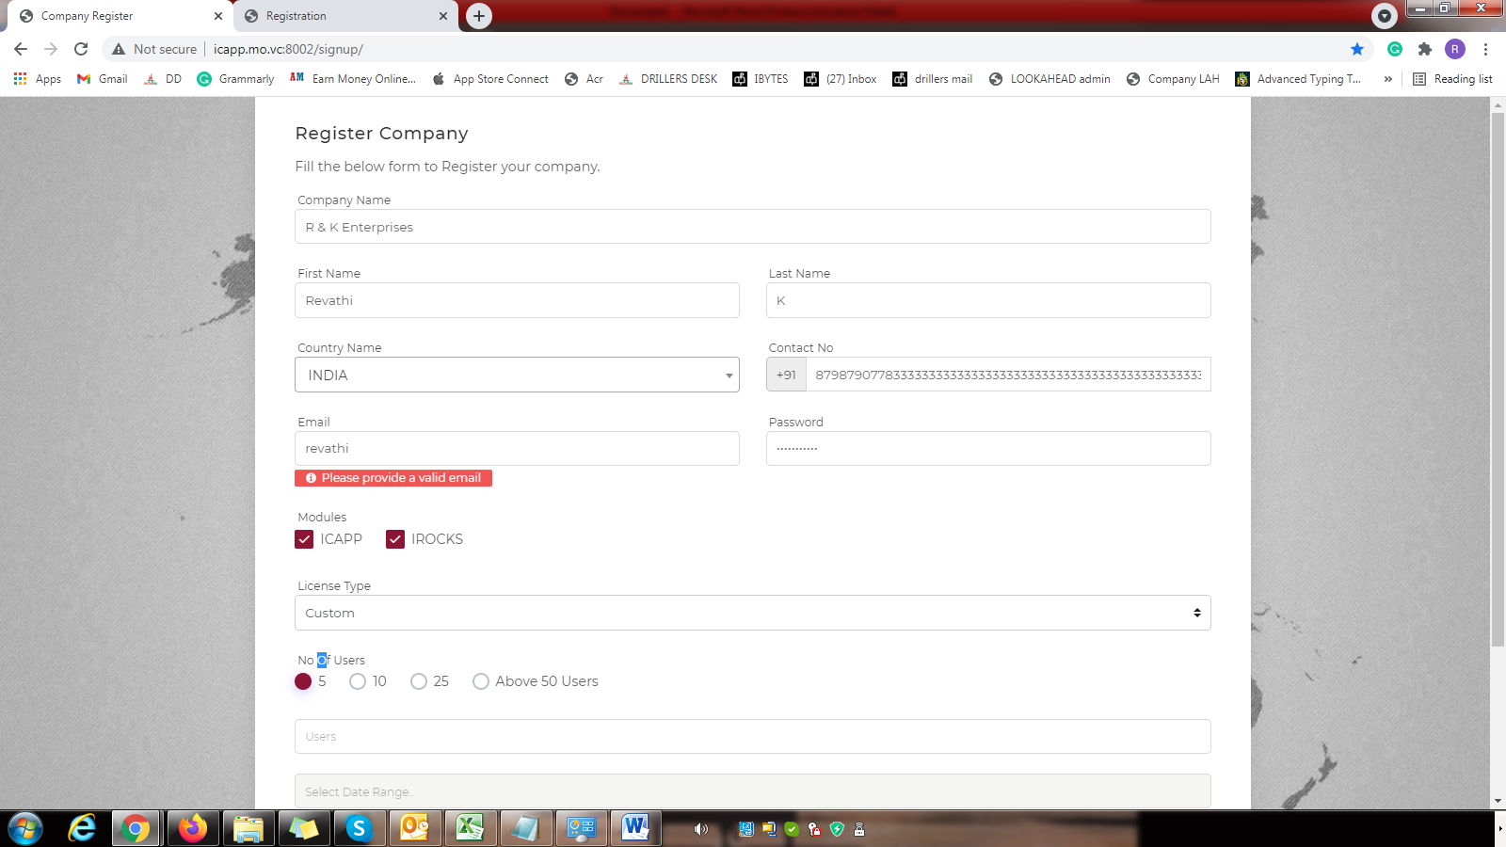
8. Can’t able to register. 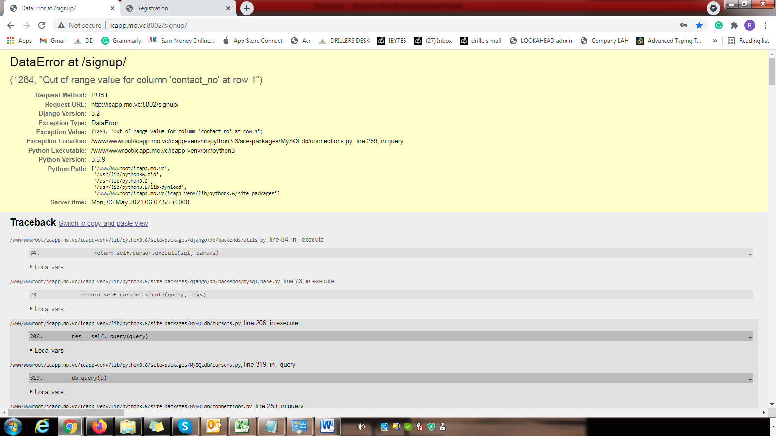
9. When we enter the country name in this field, it should display the country name. 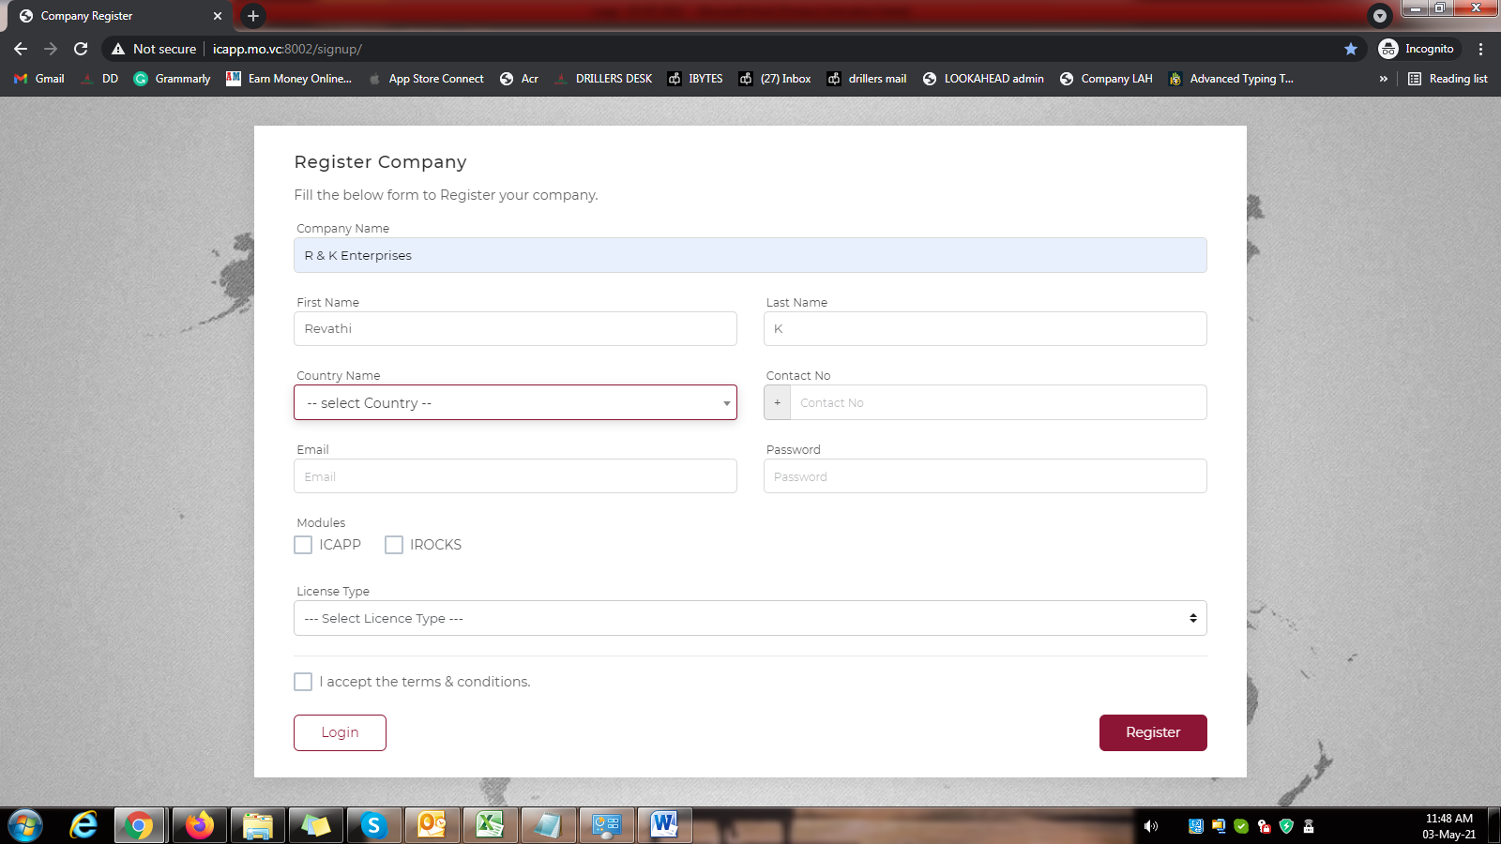
10. It should vanish after 5 seconds. 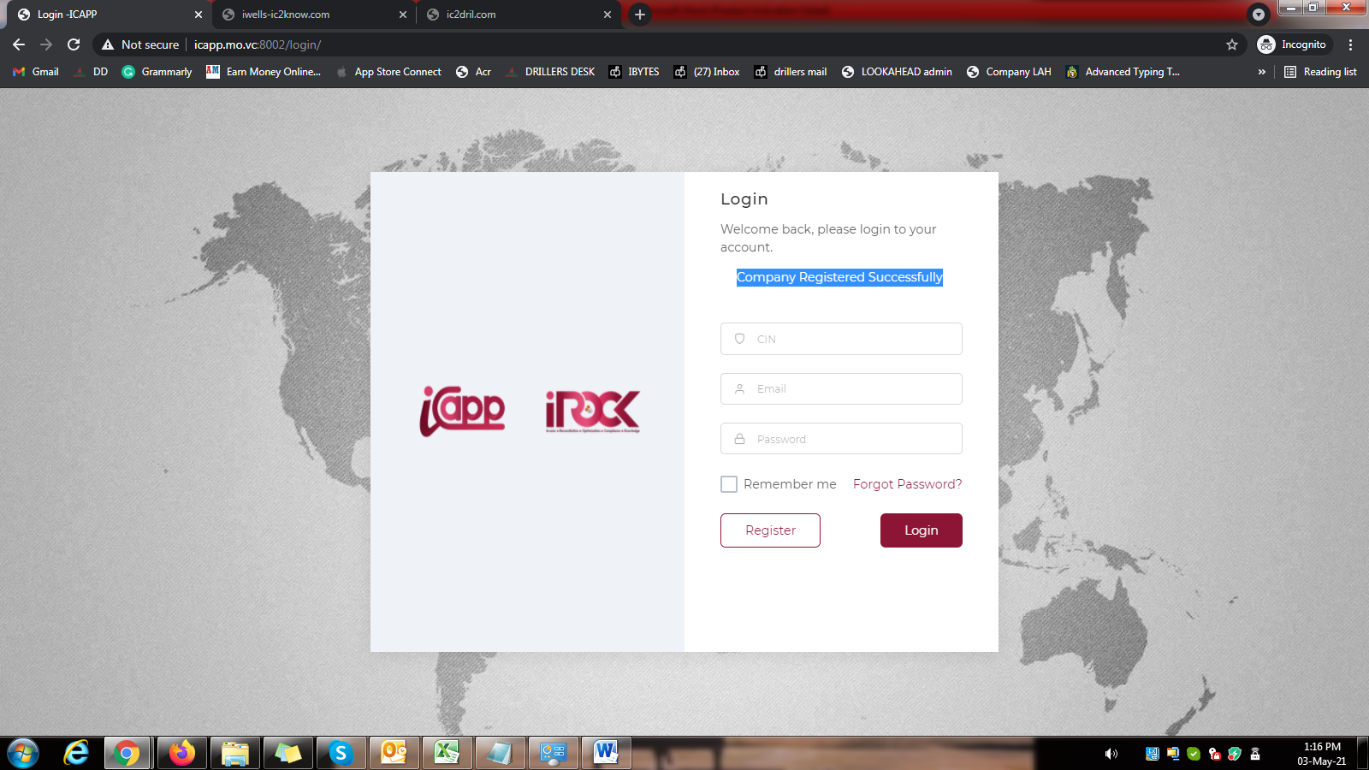
11. Give it in center. Check the spelling correction. 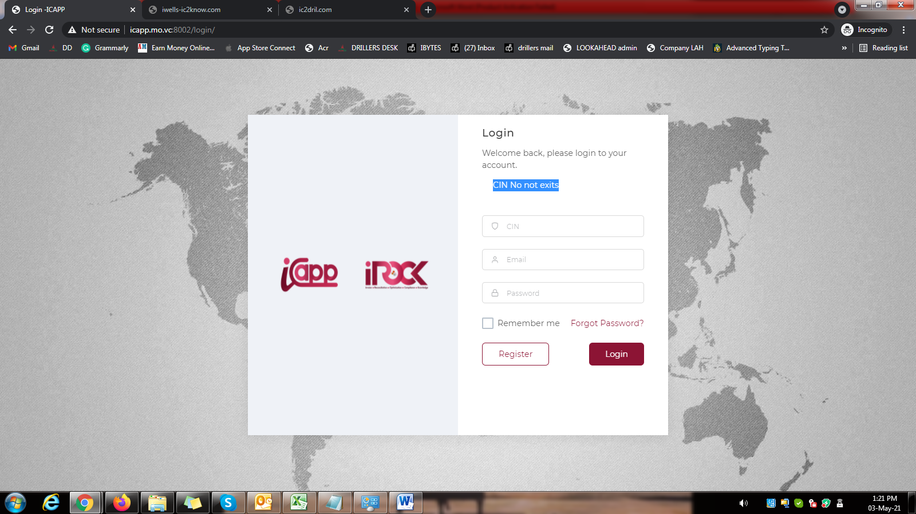
12. Change it as “Mail ID” 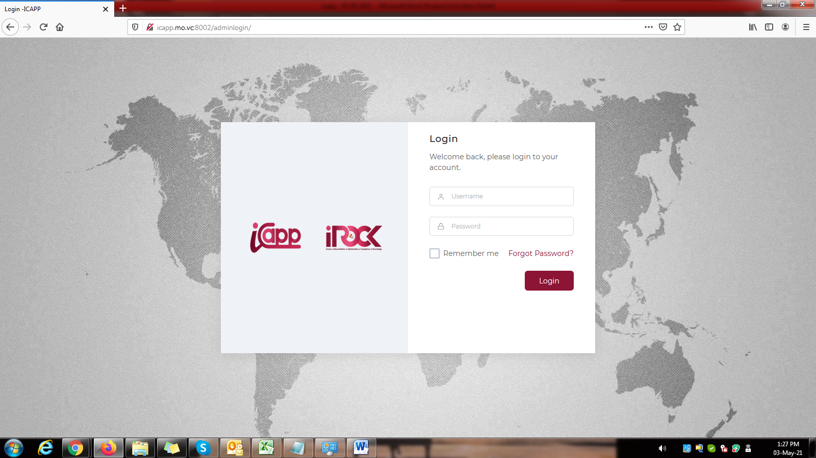
13. Give “Login” in center. 
14. Give mail ID and Password validation.

Password warning: “Password should have minimum 8 letters consisting atleast one from A-Z, a-z, 0-9 and special characters”

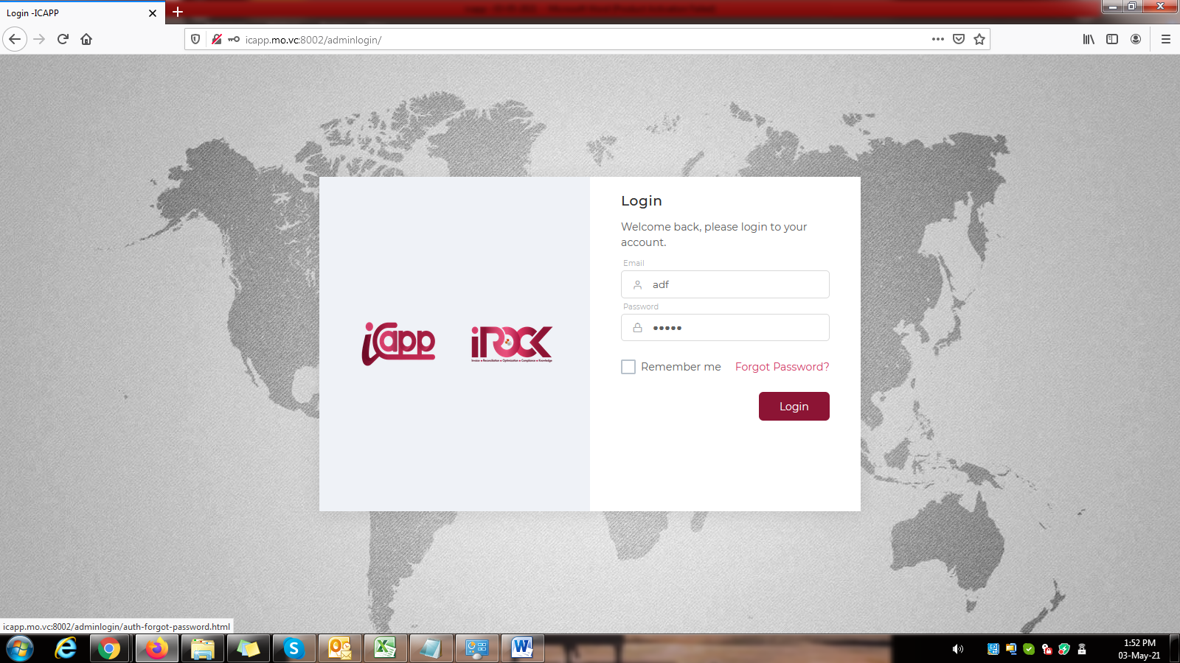

1. Forgot password is not working. 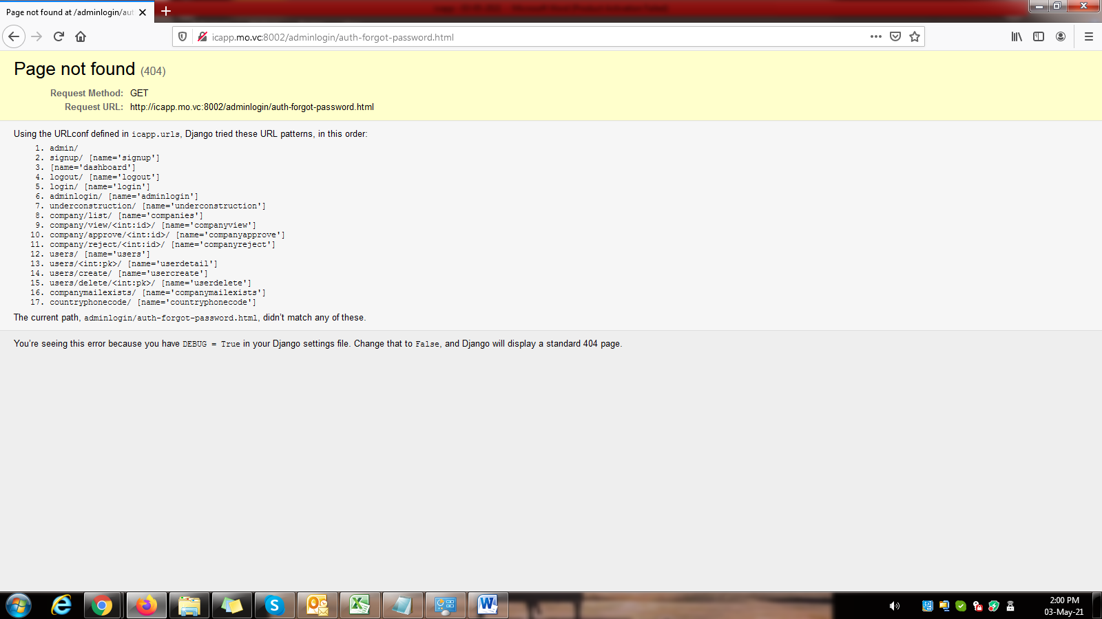
2. Give Login in center. 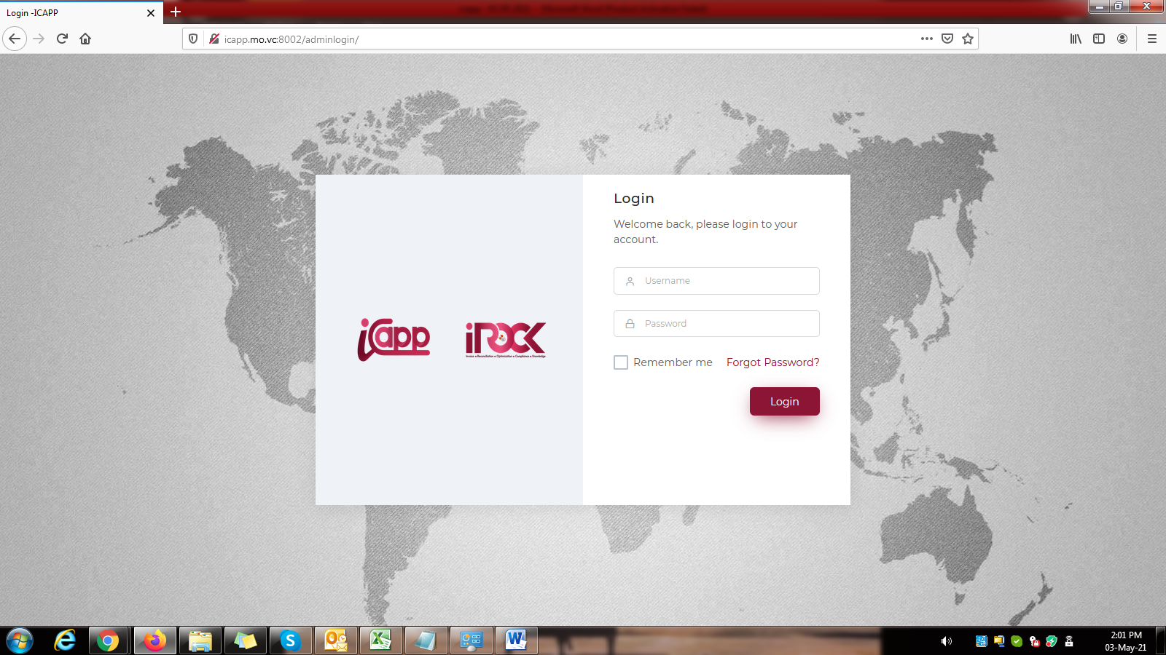
3. Give Titles in center alignment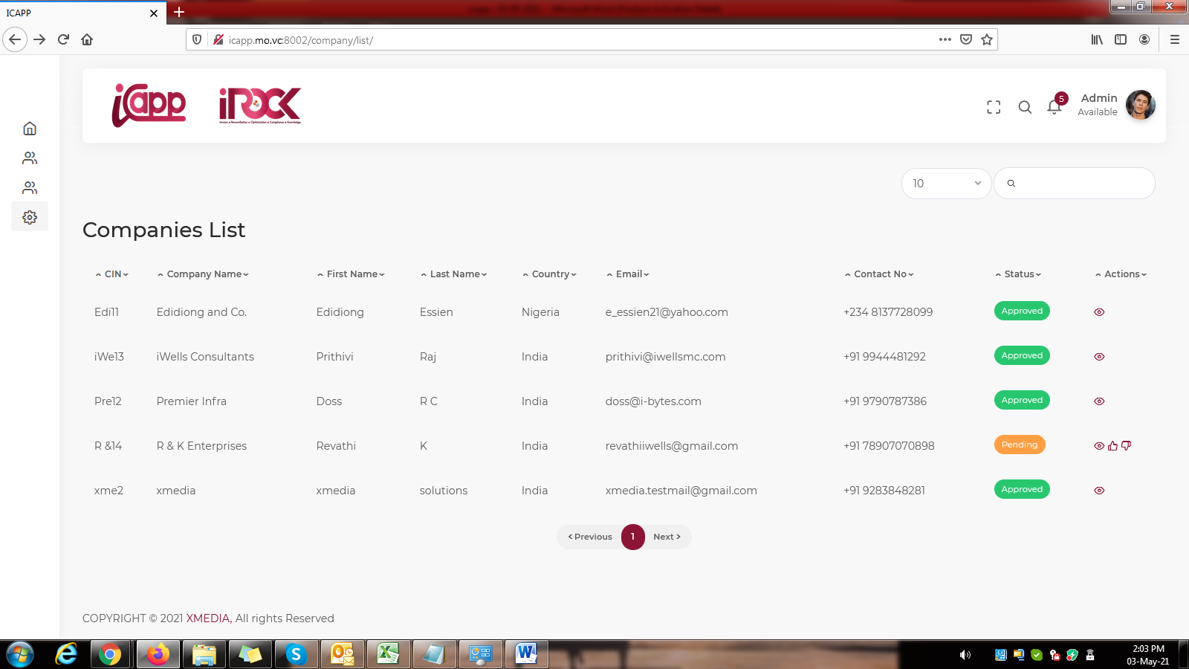
4. CIN number should not take the spaces and special characters. **Give it as like LAH.**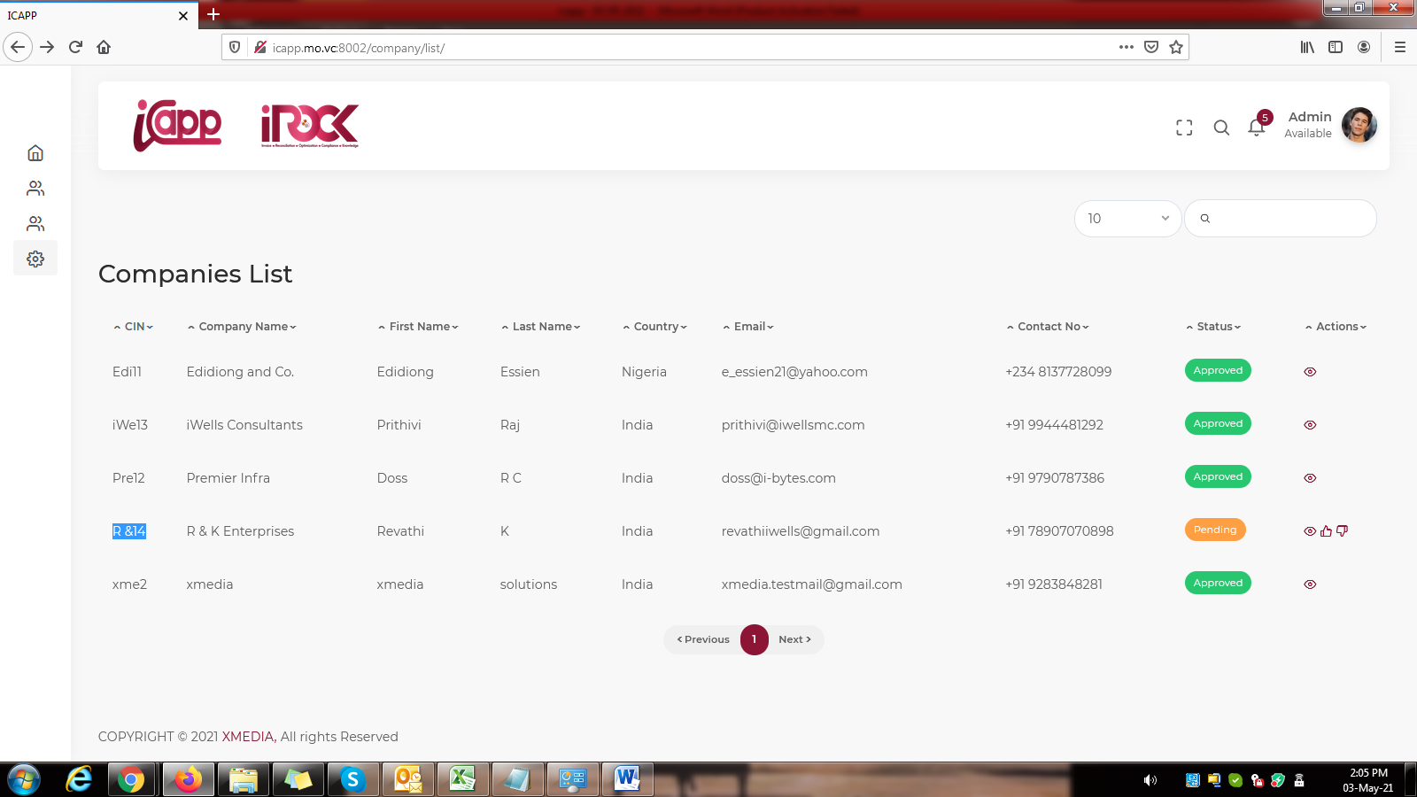
5. Give mail ID and password validation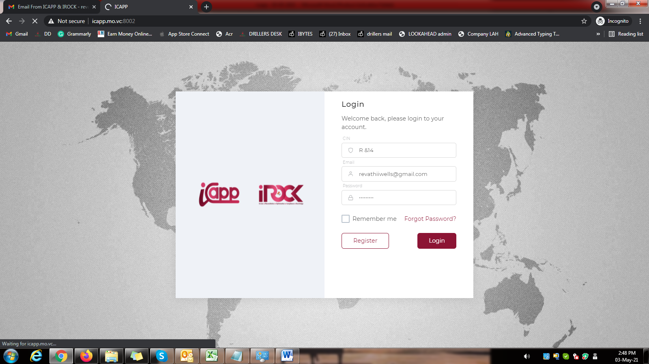
6. Give “Login” and “Register” to “Sign In” and “Sign Up” in all places.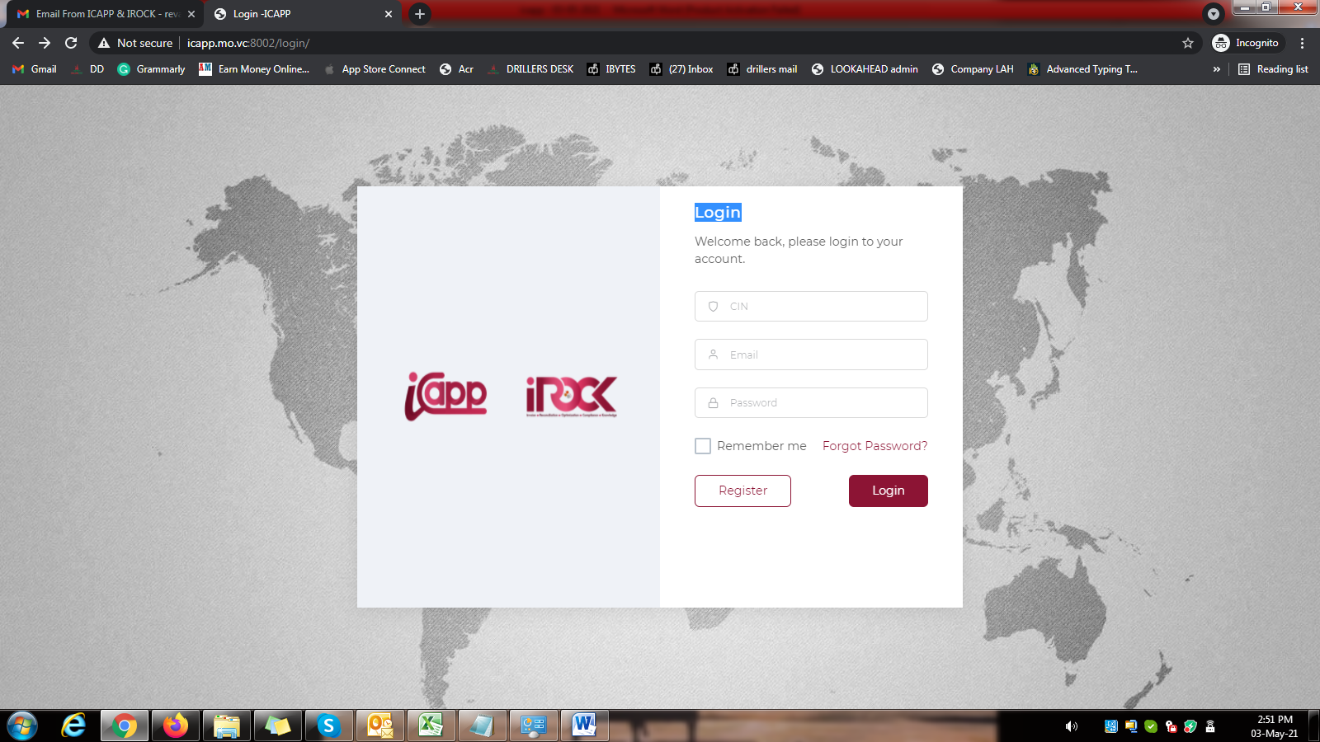
7. Give Actions in center alignment. 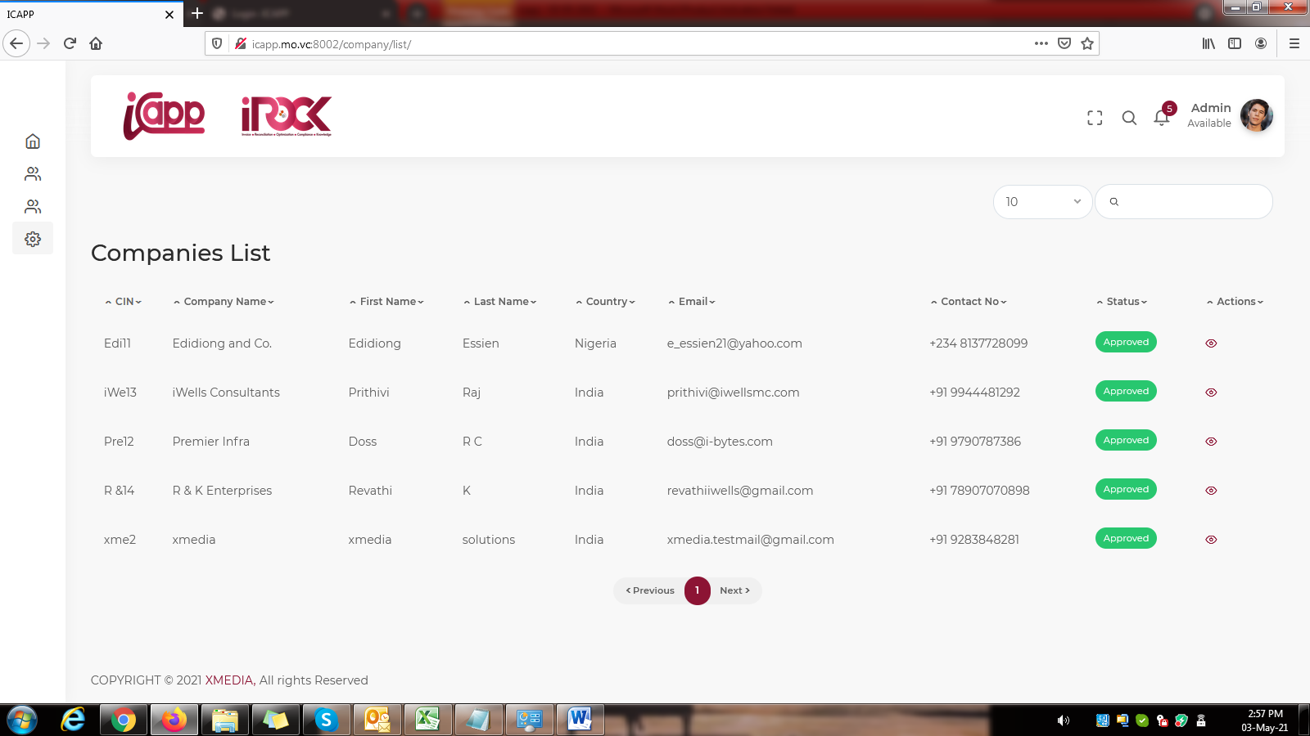
8. Give the users, projects and Time in center alignment. 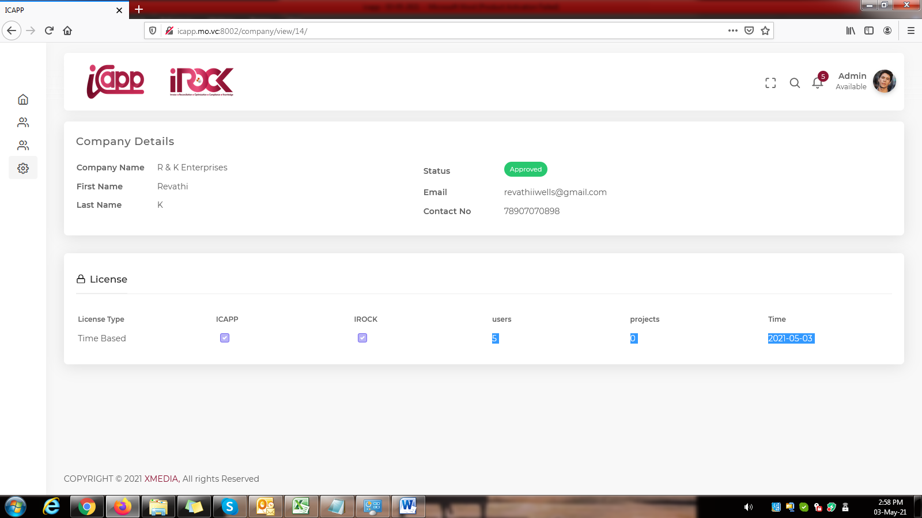
9. Change it as “Users” and “Projects” 